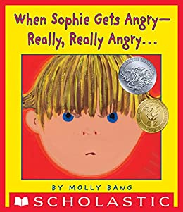

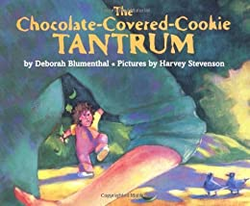

<https://www.youtube.com/watch?v=j3BCYNnOGxc> <https://www.youtube.com/watch?v=zt-hrM4cWLE>

**Social and Emotional Development Activity: Mad Face, Scary Face**

Expressing ideas for dealing with feelings helps children improve coping skills and self-expression, and also assists with problem solving and creative thinking.

Materials:

• Books about feeling angry or being scared

• Large piece of paper

Stuffed animal or puppet What to do:

1. Read aloud a book about feeling angry. Good choices are When Sophie Gets Angry — Really, Really Angry… by Molly Bang or The Chocolate-Covered-Cookie Tantrum by Deborah Blumenthal.

2. Talk about the character and what made her angry. Share something that makes you angry.

3. Introduce a stuffed animal or puppet. Tell the child about something that made this animal very angry. Ask the child for advice. What should she do?

4. Make a list of the child’s suggestions on the paper. Guide the discussion and add your ideas only if it is needed.

Suggestions might include using your words, telling a grownup, having quiet time alone, pounding clay, scribbling really fast with crayons, or making an angry face.

5. Remind your child it is OK to feel angry but you have to decide how to act angry in an OK way